**Iraqi Refugees**

**An Ongoing Crisis, A Broken Obligation**

**A talk by Becca Heller**

*Director, Iraqi Refugee Assistance Project*

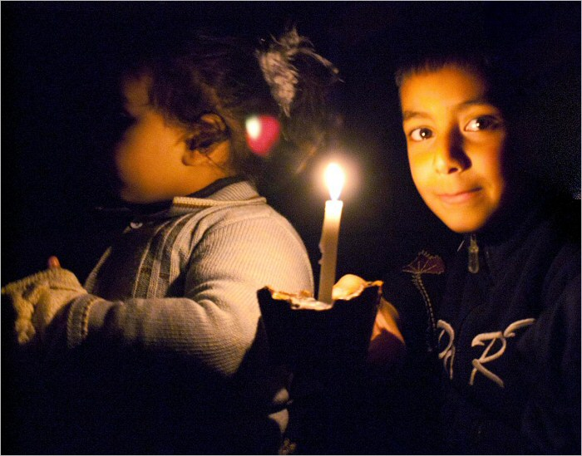

**Thursday, Sept. 29, 2011 at 7:00pm**

**Albany College of Pharmacy and Health Sciences**

**Student Center Room 202**

**106 New Scotland Avenue**

**Albany, NY**

Presented by The Iraqi Refugee Project (a coalition of Women Against War, Bethlehem Neighbors for Peace and Women’s Association for Family Affairs), Albany Law School Chapter of Amnesty International, the International Law Society and USCRI Albany.

**For more information call: Iraqi Refugee Project at (518) 392-9477 or visit their website:** [**www.womenagainstwar.org**](http://www.womenagainstwar.org)**.**

The Iraqi Refugee Assistance Project (IRAP) organizes law students and attorneys to provide legal representation to those who have none. They help Iraqi refugees navigate the rules and processes of resettlement in the US. Their work helps families escape from harm and persecution. IRAP and Albany Law School are in the process of establishing a chapter at Albany Law School.